Students' Guide for NEET Program
Online Application

- Open the website http://apply.yrcti.cucas.cn/, and click the“Sign up” at the bottom left. You can start your registration.
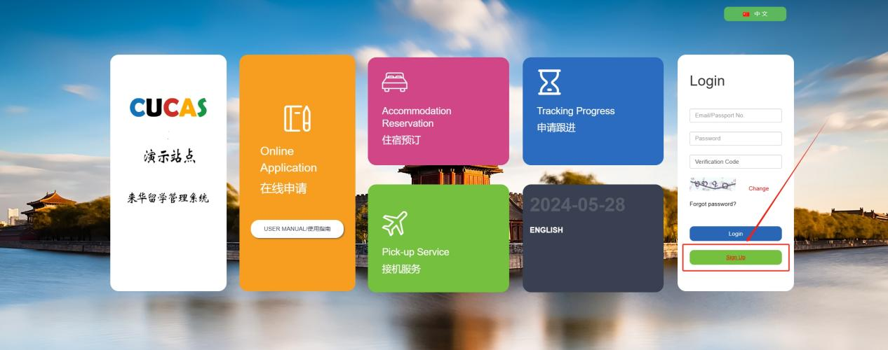
- According to the required procedures, pleases use your E-mail to register.
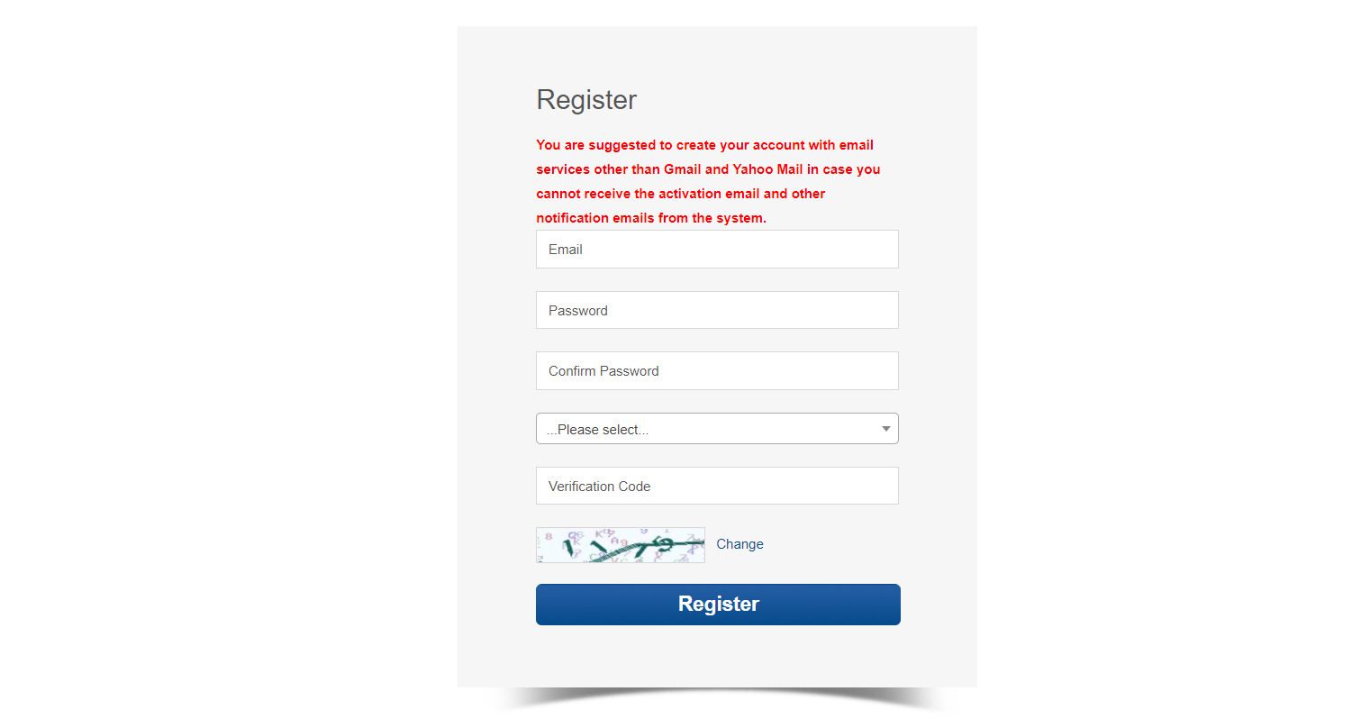
- After the registration, you can log in your E-mail to verify and activate the E-mail, in order to receive the reminder mails later.
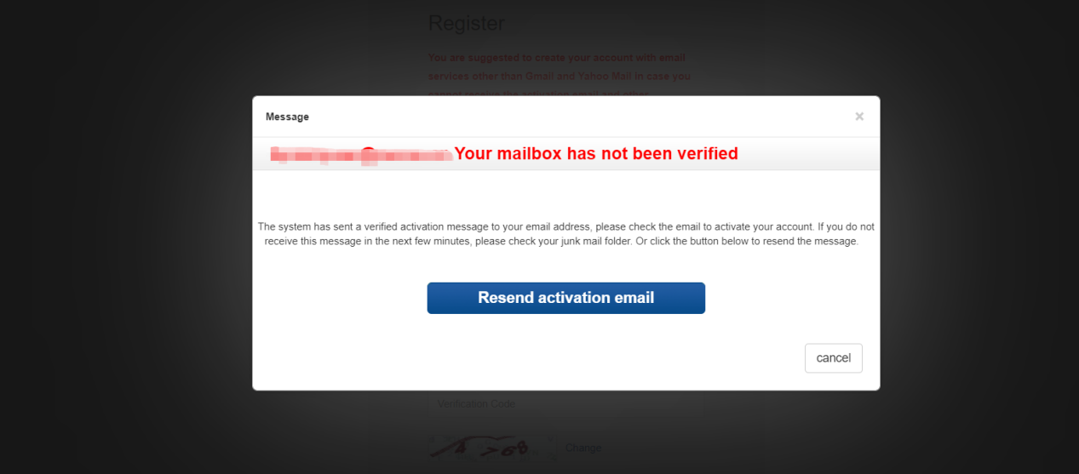
- After the account is activated, use the registered email to log in.
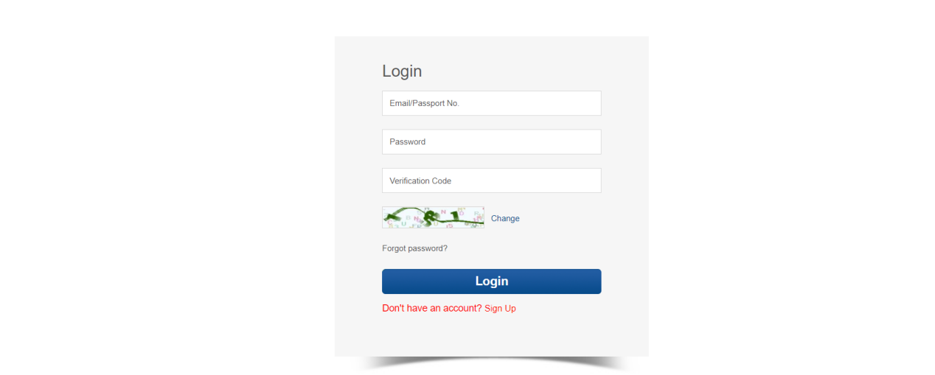
- After you log in the system, click the “My Application”, then you can turn into Program Applying.
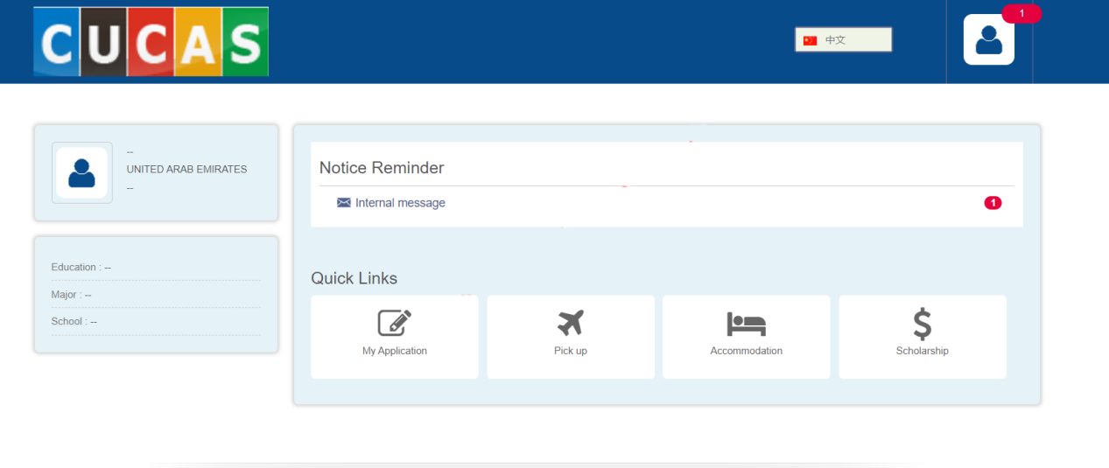
- If you want to switch other languages, please click on the top-right corner to do so. And then you can click the “APPLY NOW” to start your application.
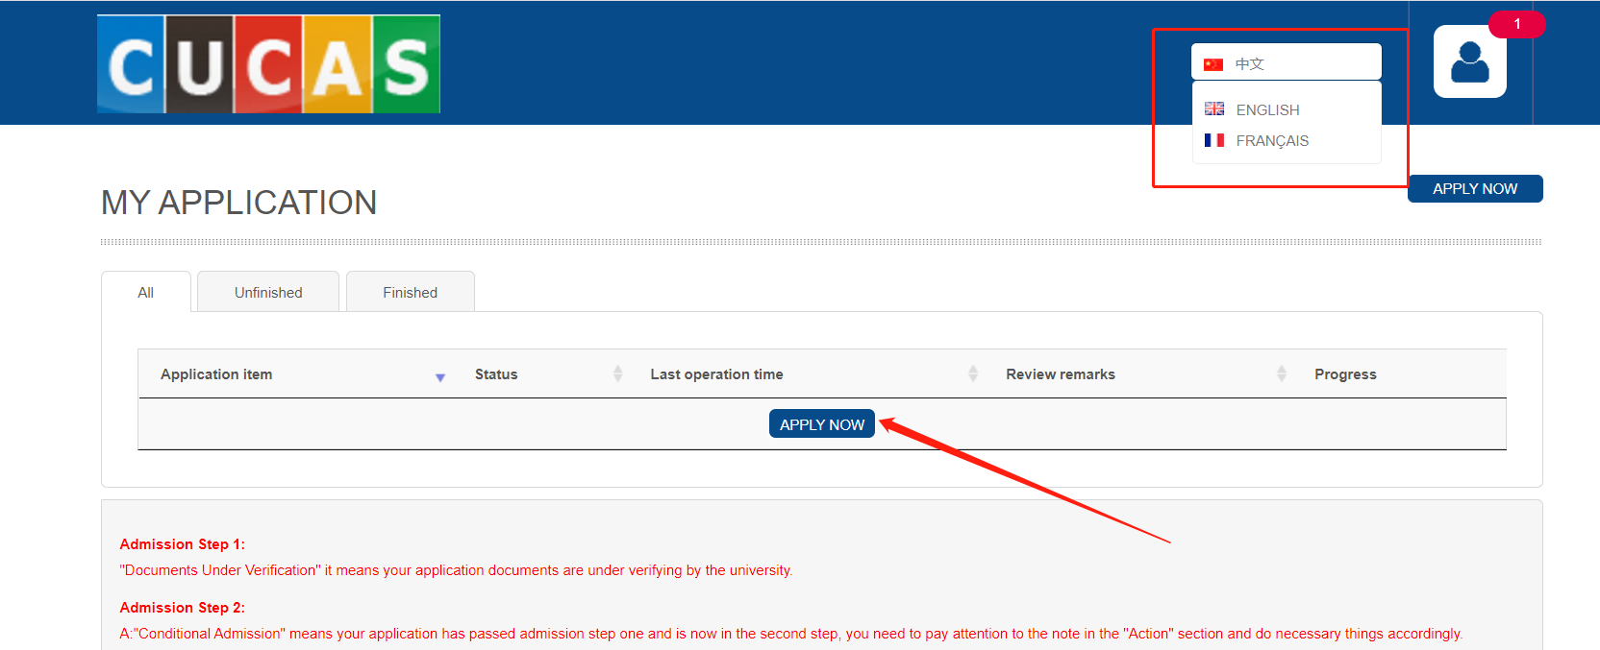
- After you choose the major and click the “Apply Now”, the page will turn into “Application Form” page.
In the "select program" section, choose "The NEET Program". Then you will see "New Energy Power Generation Technology" in the "major title" section. Click "apply now". (Note: It is essential to select "associate degree" and "The NEET Program"; otherwise, Chinese institutions will not be able to search for your personal application.)
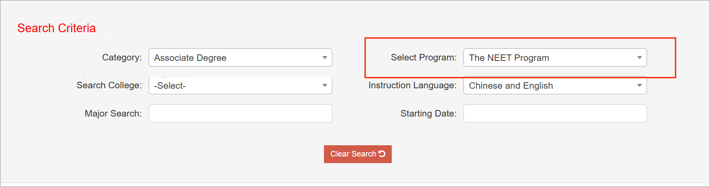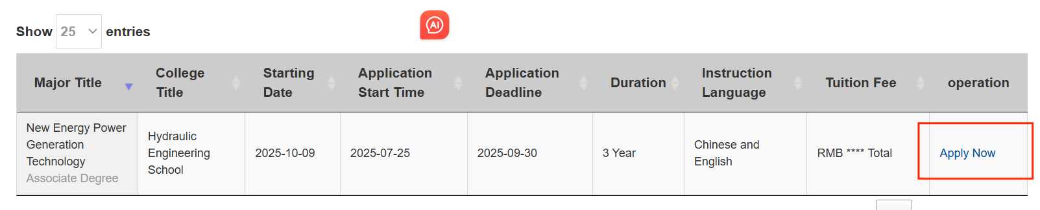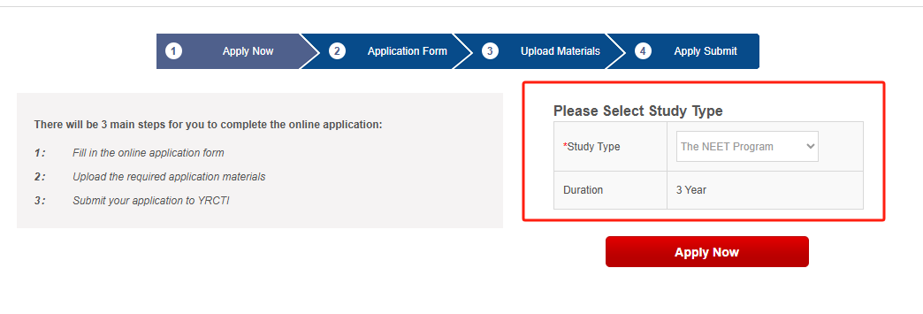
- Fill the Application From (items with “*” is necessarily), and click “Next”.
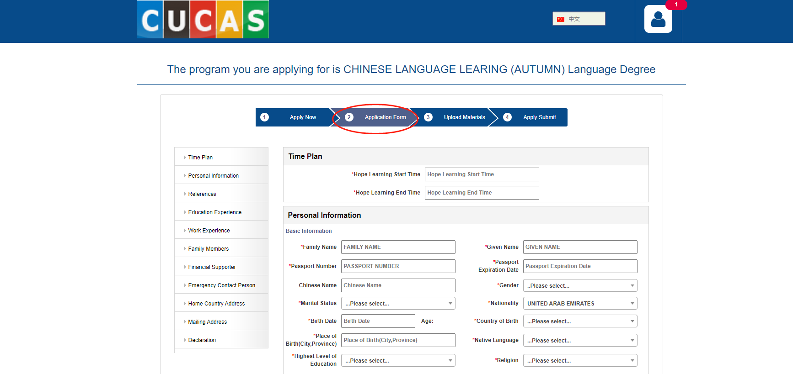
- Please upload the materials (items with “*” is necessarily), and click “Next”.If you do not currently have your passport or medical examination report, you may upload a photo of your ID or other supporting documents as a temporary substitute.
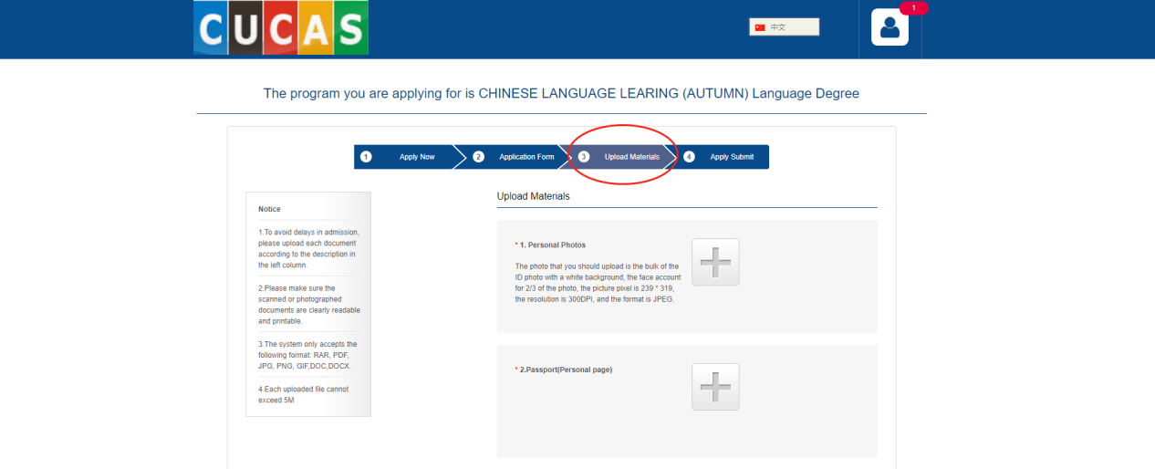
- In the “Apply Submit” page, you need to submit your application.Note: Please confirm that all information and documents are correct before clicking "Submit" – no modifications can be made after submission.
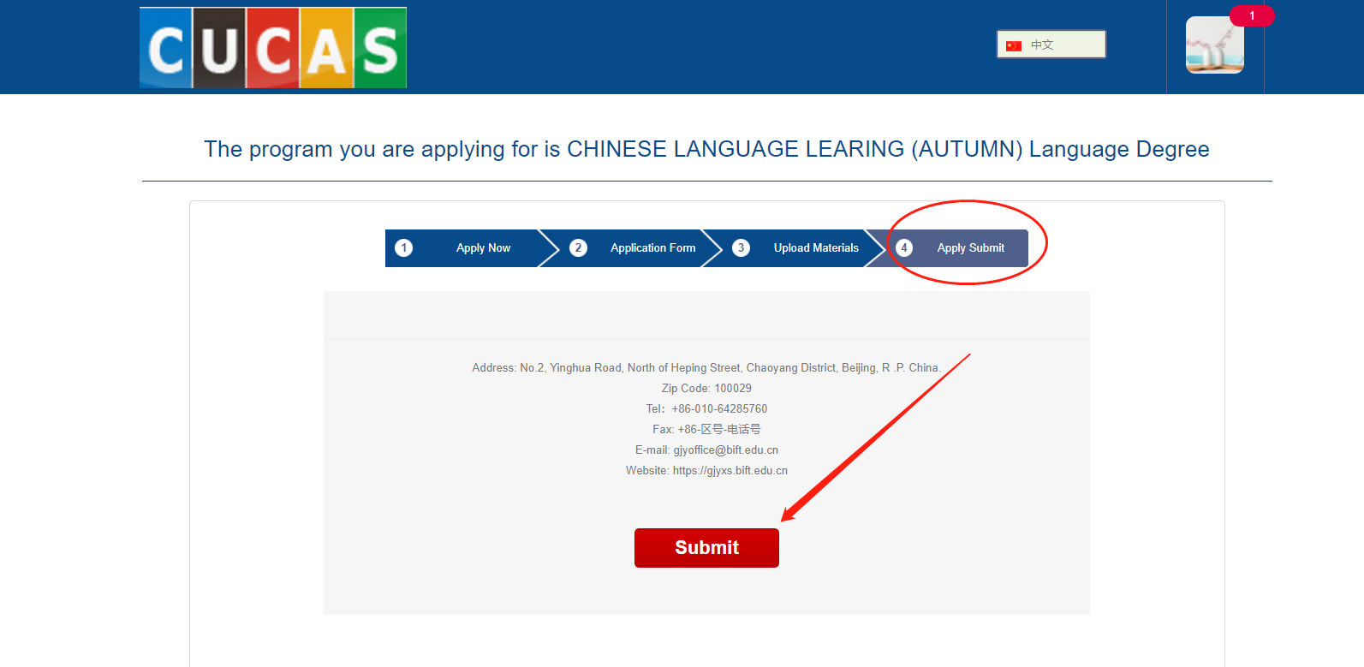
- After the application is submitted, you still need to finish 2 psychological tests to be able to view the application review process and preview the application form.
